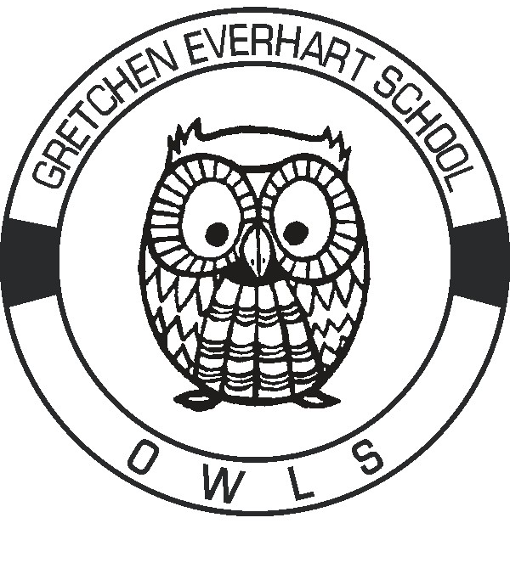

**Gretchen Everhart School**

**Student Supply List 2024—2025**

**Below is a list of suggested items for each grade level to help make it a successful year**

**Each student needs a backpack labeled with their name on it**

**with at least one set of spare clothes**

**Elementary**

Antibacterial Hand Soap (2) Clorox Wipes (1)

Waterless Hand Sanitizer (1) Facial Tissues (2)

Quart Zip lock Bags (2) Elmer’s Glue Sticks (6)

Baby Wipes (1) Colored Dry Eraser Markers (1)

**Middle School**

Antibacterial Hand Soap (2) Baby Wipes (1)

Waterless Hand Sanitizer (1) Facial Tissues (2)

Quart Sized Ziploc Bags (1) Gallon Sized Ziploc Bags (1)

Elmer’s Glue Sticks (6) Clorox Wipes (1)

Colored Dry Eraser Markers (1)

**High School & Transition**

Colored Dry Eraser Markers (1) Baby Wipes (1)

Facial Tissues (1) Clorox Wipes (1)

Glue Sticks (2) Waterless Hand Sanitizer (1)

Liquid Hand Soap and refills Pens

**Items that can always be used by all throughout the year:**

**Clorox Wipes (1)**  Antibacterial Hand Soap

**Baby Wipes**  Waterless Hand Sanitizer

Facial Tissues Zip Lock Bags

Paper Towels Edible reinforcers, snacks

Fidgets Headphones

Personal care items: toothpaste/toothbrush, 3 in 1 body wash, deodorant, etc.

Walmart/Target gift cards for snacks and reinforcers

Snack items such as: Goldfish crackers, Cheez its, M&Ms, Skittles, small marshmallows, pretzels, Starbursts, gummy bears, & fruit snacks, popcorn, crackers, small cookies, animal crackers, granola bars, etc.